Minutes of Monthly Meeting of East Cork Municipal District Held on 8th September, 2020 at 10.30 a.m. at Mall House, Youghal, Co. Cork.

I Lathair: Cathaoirleach Michael Hegarty presided.
Cllrs. Linehan Foley, Quaide, Collins, McCarthy, Ahern & Twomey.

Ag Freastal: Mr. Dave Clarke, Senior Executive Engineer.
Mr. Joe McCarthy, Municipal District Officer.
Mrs. Helen Mulcahy, (Youghal Office).
Mrs. Geraldine O’ Connell (Youghal Office).

- Confirmation of Minutes of Municipal District Meeting held on 8th September, 2020, and Special Meeting (In Committee) – County Development Plan Review held on 7th September, 2020 and Special Meeting (In Committee) – Barrack Road Housing Scheme, Youghal, held on 7th September, 2020.

Confirmation of Minutes of Municipal District Meeting held on 8th September, 2020 and Special Meeting (In Committee) – County Development Plan Review, held on 7th September, 2020 and Special Meeting (In Committee) - Barrack Road Housing Scheme, Youghal, held on 7th September, 2020 were adopted on the proposal of Cllr. Hegarty, seconded by Cllr. Ahern and unanimously agreed by the Members.

2. Matters Arising from Minutes:

No matter arose.

- Consideration of Reports and Recommendations.

3.1 Progress Report on the East Cork Municipal District Roads Programme, 2020.

Mr. Dave Clarke, Senior Executive Engineer circulated the following East Cork Municipal District Roads Programme, 2020 to the Members.

Funding Grant Category | Project Number | Road Class | Road Number | Road Name and or Townland Name | Length of Work (m) | % Completed
 | - | R | - | Regional Road Surface Dressing | 5,900 | 71%
 | - | L | - | Local Roads Surface Dressing | 26,000 | 88%
Restoration Maintenance Subtotal = |  |  |  |  | 31,900
Restoration Improvement | 1 | LP | L-3601-53 | East Cork – L-3601 Walshtown | 1,600 | 100%
Restoration Improvement | 2 | LP | L-3679-0 | East Cork – L3679 Cliff Road Ballycotton | 600 | 100%
Restoration Improvement | 3 | LP | L-3642-25, L-3642-28 | East Cork – L3642 Ballyvoon to Ballynookery | 1,000 | 0%
Restoration Improvement | 4 | LS | L-7690-0, L7691-0 | East Cork – L77691/L7690 Glengarrif More, Dundullerick West and Ballynaskeha | 2,150 | 100%
Restoration Improvement | 5 | LP | L-3628-0 | East Cork – Whiterock from N25 to Thades Cross | 1,500 | 15%
Restoration Improvement | 6 | LS | L-3629-0, L7657-0 | East Cork – L3629 Bawnard to Rathcoursey to East Ferry | 4,000 | 100%
Restoration Improvement | 7 | LP | L3602-16 | East Cork – L3601 (Part) at Broderick’s X | 600 | 100%
Restoration Improvement | 8 | LT | L-9528-0, L95282-0 | East Cork – L9528 Store Street/Greens Quay | 150 | Contract Awarded
Restoration Improvement | 9 | R | R-633-31, R-633-67 | East Cork – R633 Crompaun to Gortavadda | 2,300 | 100%
Restoration Improvement | 10 | LS | L-7814-0 | East Cork – L7814 Ardglass towards Gurteen Phase 2 | 350 | 100%
Restoration Improvement | 11 | LS | L-7825-0, L78251-0 (part) | East Cork – L7825 Kilcounty X to Ballyre X | 1,200 | 100%
Restoration Improvement | 12 | LS | L-7839-0,L-7840-0 | East Cork – L7840 Drishane More | 1,500 | 100%
Restoration Improvement | 13 | LS | L-7811-0 | East Cork – L7881 Rooskagh Shanagarry | 1,700 | 90%
Restoration Improvement | 14 | LS | L7806-0, L-7806-31 | East Cork – L7806 Lyre to Breeda Road | 1,000 | 100%
 | RESTORATION IMPROVEMENT SUBTOTAL*= |  |  |  | 19,650
 | TOTAL ROADS PROGRAMME = |  |  |  | 51,550

3.2 Progress Report on East Cork Municipal District Active Travel Measures

Mr. Dave Clarke, Senior Executive Engineer circulated the following Progress Report on the East Cork Municipal District Active Travel Measures to the Members:

East Cork Municipal District – Active Travel Measures – Progress Report 30th September 2020
Road Number | Description of location of proposed scheme | Details of Active Travel Scheme | Length (m) | Allocated Budget | Status
L-3656 | Kennel Road, Knockgriffin, Midleton | Widen existing very narrow footpath | 165 | €24,750 | Completed
L-3679-0 | Cliff Road, Ballycotton | Resurfacing of shared surface road, provision of road markings and bicycle stands | 635 | €110,000 | Surfacing Completed
R-626 | Elsinore to Elm Grove, Midleton | Reconstruction and widening of footpath linking main residential area to Educate Together National School | 80 | €12,000 | Completed
L-3805 | Castlemartyr to Mogeely Road | Widen existing footpath in order to improve accessibility | 150 | €22,500 | Tender awarded – programmed late 2020/early 2021
R-907 | Main Street Midleton adjacent to junction of Connolly Street | Raised controlled pedestrian crossing (zebra) | N/A | €25,000 | Completed
R-632 | Ladysbridge to Castlemartyr Road | Provision of road markings and bollards to delineate footpath | 170 | €5,000 | Completed
L-9425 | Broomfield Village Spine Road | Provision of 4 raised uncontrolled pedestrian crossings, 2 controlled raised pedestrian crossings, and 2 ramps to replace existing deficient ramps; associated road resurfacing and relining (Exact detail subject to design) | 700 | €270,000 | Tender awarded – programmed late 2020/early 2021
L-3810 | Upper Cork Hill, Youghal | Widen existing footpath in order to improve accessibility | 150 | €22,500 | Tender awarded – programmed late 2020/early 2021
L-9528 | Store Street, Youghal | New footpath/improved footpaths and associated drainage | 75 | €30,000 | Tender awarded – programmed late 2020/early 2021
L-7900-0 | Ballyclamasy, Summerfield, Youghal | Provision of new footpath & public lighting | 135 | €38,000 | Design stage – construction 2021
R-634 | Youghal | Relining approach roads to Youghal Town to visually narrow road | 4,000 | €10,000 | Ongoing
R-634 | Youghal | Driver feedback signage – 3 locations | N/A | €12,000 | Procurement/siting design progressing
 |  |  |  | €581,750

3.3 Progress Report on East Cork Climate Change Adaptation Projects:

Mr. Dave Clarke, Senior Executive Engineer will circulate the progress report on the East Cork Climate Change Adaptation Projects to the Members.

3.4 Section 38 Update on Proposed Traffic Calming Works at R360 Aghada/Rostellan.

Mr. Dave Clarke, Senior Executive Engineer informed the Members that 3 submissions were received in relation to the proposed traffic calming works at R360 Aghada, one submission was received from An Garda Siochána supporting the works and two submissions were received from local businesses who have met with the Project T eam on site resulting in minor changes being made to the proposed works. The Engineer will circulate the changes made in due course.

The Engineer informed the Members that no submissions were received in relation to the proposed works for Rostellan and stated that a contractor is waiting to start the proposed works as early as next week.

3.5 Section 38 Update on Proposed Traffic Calming Works at R907 Midleton and R634 Youghal.

Mr. Dave Clarke, Senior Executive Engineer informed the Members that 3 submissions were received in relation to the proposed two pedestrian crossings at the Credit Union and Youghal Fire Station, the submissions were received from An Garda Siochána, Youghal Credit Union strongly supporting the works and from the residents of Strand Street looking for the provision of a crossing on Strand Street. The Engineer informed the Members that there are no proposed changes to the works and stated that a report would be sent to the Director later this week.

3.6 Municipal District Officer’s Report for October 2020.

Mr. Joe McCarthy, Municipal District Officer circulated the following Municipal District Officer’s Report for 2020 to the Members:

General Municipal Allocation 2020 (Community Fund Grants).

At their meeting held on the 3rd of June, 2020, the Members considered 108 applications and approved grants totalling €241,300 to community, arts and heritage and sporting groups throughout the Municipal District.

2020 Amenity Fund.

A total of €110,425 was allocated to the Amenity Fund for 2020 and a total of €11,600 has been claimed to date.

2020 Community Contracts Fund.

A total of €55,875 was allocated to the Community Contracts Fund for 2020 and a total of €9,600 has been claimed to date.

2020 Capital Fund.

A total of €75,000 was allocated to the Capital Fund for 2020 and nothing claimed to date.

Midleton to Youghal Greenway.

The contract for vegetation clearance for the Midleton Youghal Greenway is now being finalised. Topographical survey of the route is ongoing and will continue over the coming months. Tenders for a Landscape Architecture and Interpretive Planning brief have been sought and are currently being evaluated and a brief for the engagement of Engineering consultancy services is now in preparation.

Midleton Town Centre Improved Access & Enhancement Project, Phase 2.

Members will be aware of the ongoing work being undertaken to finalise the design and tender documentation for this complex project. Whilst it was expected to go to tender in March, this did not happen as there were additional amendments required to the tender documentation to incorporate the recommendations of a pre-construction Stage 2 Road Safety and other Accessibility Audits.

Current indications are that the Consultants working on behalf of CCC will have the final set of amended tender documents available this week for review by CCC in advance tender advertisement.
It is imperative that the tender documentation issued is as comprehensive and complete as possible to enable contractors to submit tenders prices and to mitigate the risk of additional cost and delays arising during the construction phase of the works.
It is envisaged that tenders for the construction Contract will be advertised at the end of next month and assuming that there are no issues with the tender process, the appointment of a Contractor will occur in Q1 of 2021.

There is a 15 month construction period allowed for the works.

St. Mary’s Collegiate Church – Youghal.

The Voices of St. Mary’s.
Fully completed. Handed over to Cork County Council and unaccompanied and accompanied tours are now available.

Phase 2 of the Youghal Eco Boardwalk.

Over 50% complete. Completion date is the 31st October, 2020, for this 1.2km extension of the Boardwalk.

Front Strand Public Convenience & Lifeguard Facility.

Construction due to start by end of 2020. To be completed Q3 2021.

Youghal Lighthouse Project.

An Architect is currently preparing designs for Phase 2 of the works which involves the construction of a viewing area on the seaward side of the building to facilitate proceeding with the Part 8 planning procedure.

Youghal RRDF Application (Courthouse) – and Public Realm.

Grant of €281,250 approved. Design Team has been appointed. Going out to Tender shortly.

Town & Village Renewal Scheme,( 2018). – Cloyne.

Litton Fountain.
This project for the repair and refurbishment of the historic Litton Fountain and for enhancement of the surrounding public realm is essentially completed.

Town & Village Renewal Scheme, (2018). – Youghal.

Market Square Dock.
This project provides for new, quality, natural stone paving, revised parking facilities and the installation of Moby Dick Sculpture at Market Square Dock.

This Project is now completed with the unveiling of the Moby Dick Sculpture, Artist Matthew Thomson, by The Mayor of Cork County, Cllr. Mary Linehan Foley, on the 12th August, 2020.

Town & Village Renewal Scheme, (2019).
In late 2019 the Council was notified that it had been successful in its 2019 Town & Village Renewal application for East Cork for the installation of a series of 8 space ‘bike racks’ in designated car parking locations throughout the towns and villages of East Cork. The proposal will promote cycling throughout East Cork, and aid the transition at a local level to a low-carbon economy.

The inclusion of these bike racks will further enhance the reputation of East Cork as an outdoor haven for cycling enthusiasts, following the hosting in East Cork of the international first full Ironman competition in the region on 23rd June, 2019.

Approximately €50,000 will be spent on this project.

Town & Village Renewal Scheme, 2020.

Accelerated Measures in Response to Covid-19.
This is a new strand of the Scheme for 2020, focussed on delivering immediate interventions that can be delivered in the short-term to assist towns and villages in adapting to Covid-19. It will target towns and villages with a population of under 10,000. The Council was successful and received a grant of €38,000 for a joint Cork County Council, Youghal Tidy Towns and Tesco Youghal proposal to develop a community garden at the Old Bridewell Gaol, Mill Road, Youghal. The project will consist of a gated community garden including an urban orchard, raised beds, seating and courtyard.

Town & Village Renewal Scheme, 2020.

Main Strand.
This will operate on the same basis as has been delivered in recent years, albeit with a particular focus an projects delivering an economic dividend and enabling towns and villages to respond to Covid-19 challenges. The Department is committed to ensuring that towns and villages most in need of support and for towns and villages which have not previously been funded under the Scheme will benefit under the Scheme in 2020.

An application for funding to facilitate the replacement of 3 no. footbridges in Glenbower Wood, Killeagh, has been submitted. This ancient woodland is an amenity which has attracted many thousands of visitors and numbers will increase significantly with the development of the MY (Midleton-Youghal ) Greenway, which passes through Killeagh Village.

Department of Agriculture, Food and Marine (DAFM).

On the 19th of May, 2020, Cork County Council received a grant of €394,500 for Fishery Harbour and Coastal Infrastructural Development across County Cork. There are thirteen (13) projects included in the Scheme which cover twenty one (21) separate piers. This grant represents 75% of overall project cost and Cork County Council will fund the remaining 25% (€131,500).
Three projects are located in the East Cork Municipal District as follows:-

Youghal Harbour – Nealon’s Quay, Market Dock and Green’s Quay.

Project Description.
Safety Improvement Works – (1) Essential Safety Measures to include handrails, toerails, replacing ladders, mooring rings, mooring bollards, storm weather gate (2) upgrade existing steps and carry out remedial works to pier wall and redeck slipway.
Estimated Cost €80,000 – Grant €60,000 – Match Funding €20,000.

Ballycotton Pier.

Project Description.
Fishermen Improvement Works: (1) Provide additional berthage at the deepest section of the pier by infilling steps (2) Fit 1 No. new navigation light at harbour entrance to improve safety of navigation (3) Install new fenders at head of main pier to prevent damage to the concrete piles supporting the main pier.
Estimated Cost €30,000 – Grant €22,500 – Match Funding €7,500.

Knockadoon Pier & Slip.

Project Description.
New concrete deck on upper section of slipway. Provide section of vertical toerails on both sides of slipway. New section at Beach and Breakwater - replace 2 No. ladders at head of Breakwater. New surface water drain with gulley adjacent to gabions. Install standardised Health & Safety (warning) signage.
Cost €18,000 – Grant €13,500 – March Funding €4,500.

The Council continues to support Youghal Socio-Ecomomic Development Group, Yew Wood Venues (Promotion of the Arts), Youghal Clock Gate Tower (Tourism), and Midleton Lodge and Baby’s Walk Public Parks Project.

PROJECT ACT (Activating County Towns), 2020.

The Project ACT Town Team for Midleton put forward three proposals:
The installation of two wheelchair accessible picnic benches, one in Baby’s Walk Park and one in Midleton Lodge Park. Funding of €700.00 was approved and benches have been installed.

The installation of 8 sets of seating and planters combined at various locations throughout the town and in two public parks. Funding of €35,528.00 was approved.

The creation of 3 entrances and the installation of a pedestrian bridge to connect three town centre public parks and significantly increase accessibility and permeability of these attractive public open space amenities. An application for funding has been submitted.

The Project ACT Town Team for Youghal put forward two proposals:

Targeted marketing campaign to bring visitors to the town centre, €18,772.00.
Streetscape Painting Scheme, €20,000.00.

This item was marked as read.

3.7 Project ACT – Countywide Overview & Key Achievements Review Report.

Mr. Joe McCarthy, Municipal District Officer circulated the following Project ACT – Countywide Overview and Key Achievements Review Report to the Members:

INTRODUCTION

In May 2020, Cork County Council announced its Project ACT (Activating County Towns) initiative across 23 towns to guide and support business, retail and communities in dealing with the impact of COVID-19.
Project ACT involved a suite of measures to support our county towns as they re-opened for business. The key objective was that Cork County Council, through its elected members and executive, would play a leadership role in planning the recovery from the impact of COVID-19, working with local stakeholders in identifying priorities and actions to support town activation, increased footfall, increased economic activity etc. A key priority was to encourage people back into our towns, make them attractive places to do business again, facilitate social distancing etc, and also to promote awareness of the range of local and national support packages that were available (including Business Restart Grant, Restart Grant Plus, Town Development Fund etc).

One of the initial steps was to put a structure in place. An internal Project ACT Steering Group was formed which guided and directed the programme of interventions. The Steering Group was chaired by Mr James Fogarty, Deputy Chief Executive, and comprised the following members:

- Ms Clodagh Henehan, Divisional Manager
- Ms Valerie O’Sullivan, Divisional Manager
- Mr Niall Healy, Director of Services, Municipal District Operations & Rural Development
- Mr Padraig Barrett, Director of Roads & Transportation
- Ms Sharon Corcoran, Director of Economic Development, Enterprise & Tourism
- Ms Loraine Lynch, Head of Finance

CARRIGALINE
Extension to Owenabue Car park complete
Car Parking Plan, associated signage, age friendly parking spaces implemented
Carrigaline Community Parklet complete
Pedestrian Crossing complete
Works to Car park at rear of Stables bar complete
Outdoor street furniture licences approved and works undertaken to accommodate same
Vacant Units Project - The Gallery, Carrigaline – launched and complete
Creative Ireland Funding Secured to promote the Arts and the newly formed Owenabue Arts Collective
Streetscape Painting and signage scheme - administered and allocated (fully subscribed)
Additional Outdoor seating installed (1 more to go in) and additional bicycle racks purchased (to be installed)
Local promotional video produced and promoted

Figure 1 Example of Arts initiative

PASSAGE WEST / MONKSTOWN / GLENBROOK
- Vacant Units Project - the convent Passage West – windows dressed / filled
- Additional Outdoor Seating installed
- Signage at pontoon installed
- Signage at rear of FOF park and on Museum ordered and awaiting installation
- Cut and Cover - Cut back of vegetation complete
- Cut and Cover Mural - brief sent to artistic co-ordinator and proposal awaited
- Painting and signage scheme administered and allocated (fully subscribed)
- CCC taking on PL insurance of public seating outside of area outside Credit Union
- Stencilling of footpath Glenbrook – Monkstown complete
- Bollards outside the Shamrock installed
- Sign for post-office funded
- New section of footpath at Glenbrook Wharf Apartments installed
- Additional cycle stands ordered and due for installation

COBH
- The design and purchase of 20 no. windbreakers, with a Cobh logo (designed by Cobh & Harbour Chamber and Cobh Tidy Towns). The windbreakers are being provided free of charge to businesses around the town that have provided outdoor seating for their customers. At the end of the tourist season, the windbreakers will be returned to the Council for storage. The windbreakers will also be available for any Council supported events in John F. Kennedy Park in the centre of Cobh.
- A Paint Scheme, concentrating on the commercial areas of the town. A total of 16 buildings across the town applied for, and were approved for grants under this scheme.
- Cobh & Harbour Chamber, Cobh Tourism and Cobh Tidy Towns worked together to arrange a leaflet drop for all houses on Great Island. The leaflets highlight the advantages of shopping locally. In addition, a small number of billboard type signs, encouraging people to shop locally, were erected on the approaches to Cobh
- Some funding was allocated towards assisting the Roads engineers with proposals to encourage social distancing on the footpaths in the town centre. These include the installation of bollards and the creation of a uncontrolled pedestrian crossing in the town
- The balance of the funding for Cobh has been allocated towards providing additional Christmas lighting for the town. A design for this is currently being prepared.

CARRIGTWOHILL
- Carrigtwohill Business Association are working on creating an online platform to promote awareness of town businesses to the management and employees of the various companies operating in a number of industrial/business parks around Carrigtwohill. The aim is to highlight the retail and other service offerings available within Carrigtwohill.
- Cork County Council and Carrigtwohill Community Association recently worked together on a major redevelopment of the Community Centre Campus. This work involved the total redesign of the existing carpark and the installation of a new playground and a Multi Use Games Area. As part of the redevelopment of the carpark, an area has been identified for use as a Markets/Events area. Under Project ACT, funding is being provided to allow the Community Association to purchase branded canopies for use in this area.
- As most of the footpaths in the town centre are narrow, and it is not possible for outside space to be provided for cafés etc., benches and planters have been installed in an area to the front of the Community Centre to provide an outside space for the town
MIDLETON
- The installation of two wheelchair accessible picnic benches, one in the Baby’s Walk Park and one in Midleton Lodge Park. This initiative was proposed by the local Older Persons Council representative who is a key advocate for people with disabilities. The picnic benches were manufactured locally and have been installed in the parks and are proving to be very popular.
- The installation of 8 sets of seating and planters combined to be located throughout the town, 4 in Baby’s Walk Park, 2 in Midleton Lodge Park and 2 in the vicinity of Midleton Courthouse. The objective is to enhance and encourage the use of public open spaces and amenities in the town centre and at the same time to extend and promote the support for pollinators and biodiversity objectives set out in the Midleton Pollinator Plan by providing appropriate attractive planting schemes at each location. The seating and planters have been ordered and will be installed on delivery.
YOUGHAL
- Introduction of one way pedestrian system on the North Main Street and access to Dolphin Square Car Park
- High visibility bollards at areas around the town where illegal parking created difficulties for social distancing.
- Social distancing markings on the North and South Main Street, The Promenade, AIB and both Primary Schools.
- Road lining improvements throughout the Town.
MALLOW
- Outdoor Seating – Parklets
Parklet Project funded and completed at Food Capers, West End, Mallow
Parklet Project Funded and completed at Brudairs Cafe, Main Street, Mallow

Applications have been received from a further 6 outlets, these are currently being considered and a decision will be made depending on location and implications on parking etc.
A Standard Operating Procedure/How to Guide was developed to guide businesses on the installation of parklets across all 23 towns in Cork County.

- Pedestrian Crossings
Funding has also been sanctioned through Project ACT for new pedestrian crossings at the following locations:

Top of St James Avenue
Bottom Fair Street
Bottom of O’ Brien Street

All of these will improve connectivity to the Main Street and will improve safety for pedestrians while complying with social distancing measures.

- Painting Scheme
3 Applications currently be processed under the Painting Scheme through Project ACT

- Free Parking
The Free Parking Initiative that was introduced as part of Project ACT in June 2020 has been extended until Feb 2021

- Street Cleaning
A deep clean of the Main Street in Mallow was also undertaken by the Roads directorate as part of Project ACT
KANTURK
- Outdoor seating – 4 no. seats on order
- Bicycle parking- 2 no. bicycle stands on order
- Finger Posting for Kanturk Castle within the town, signs on order
- Painting Scheme of Business properties - works complete
- Kanturk Playground Match Funding - works ongoing.
NEWMARKET
- Paving of 2 no. parking spaces outside restaurant at Main cross provision of public seating area with floral display- Ground works complete, Furniture and planters on order.
CHARLEVILLE
- Shop on Your Doorstep campaign to include a voucher booklet incorporating all businesses who wish to take park in promoting shopping in Charleville.
- Deep Clean of Town Centre.
- Temporary bollards were erected in key locations
- New street furniture Installed which included planters & seats.
- Town ambassadors patrolling the town.
Charleville Paint Scheme under Project ACT
- 4 no. successful applicants with 2 projects near completion.
BUTTEVANT
- Outdoor Seating
2 Applications received for outdoor seating
- Tree Planting
Replacement of trees in planter on Buttevant Main Street funded through Project Act
- Street Cleaning
A deep clean of the Main Street in Buttevant was also undertaken by the roads directorate as part of Project ACT

FERMOY
- 2 x parklet Kiosks - Kiosks ready for delivery, locations to be decided.
- Fermoy Forum – proposed Fermoy Voucher scheme - works ongoing to finalise an app to facilitate on line voucher.
- Footpath works at Mill Island car park & Fitzgerald place, pedestrian crossing at Pearse Square – footpath works to be complete by mid November.
- Fitzgerald Place/Market Place Fermoy - defined walkways, lighting, seating, planting, outdoor power points, power point locations to be decided, project to be complete by mid November.
- Waterloo Lane, Fermoy -proposed outdoor seating, lighting, removal of old trees - draft plans developed, consultation to take place with local residents, project can then be progressed.
- Paint Scheme – significant painting works in town centre’s Pearse Square completed. Two further applications in progress.

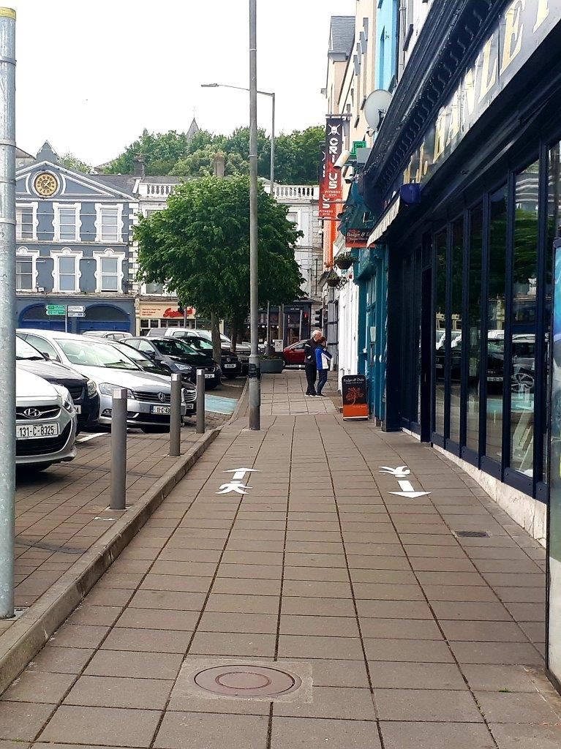
Figure 2 Example of footpath lining in Fermoy
MITCHELSTOWN
- Temporary widening of footpaths to facilitate social distancing
- St Georges - access door improvement works, sanitising measures, works have commenced on access, hand sanitising measures are in place.
- Upgrade public lighting rear laneway lower Cork St & Footpath Works, Public lighting contract in hand, footpath works to commence mid October.
MACROOM
- Deep clean of town
- Painting of interior of public toilets
- Painting of exterior of Town Hall (windows, railings, doors etc)
- Deep clean of Castle Gates
- Repointing of cobblestones at Castle Gates
- Painting of cannon + flower bed at Castle Gates
- Painting of poles, water pump, flower beds etc
- Installation of 2no street canopies – 1 at South Square & other at Town Hall
- Waiting on delivery of disability accessible picnic benches for installation in the canopies
- Planters to be procured for the canopies shortly

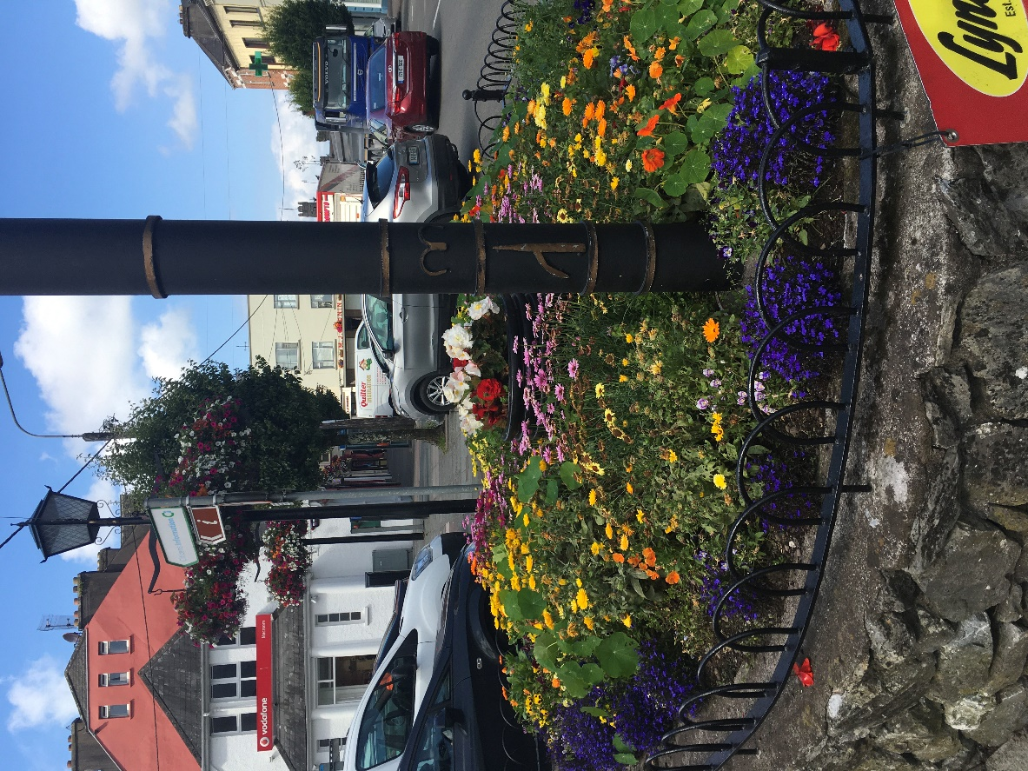
Figure 3 Example of newly planted flowers in Macroom

MILLSTREET
- Deep clean of town
- Social distancing street markings placed for school warden
- Installation of 2no street canopies – 1 at the Square & other at the church
- Waiting on delivery of disability accessible picnic benches for installation in the canopies
- Painting of interior of public toilets + exterior of Carnegie Hall to commence shortly

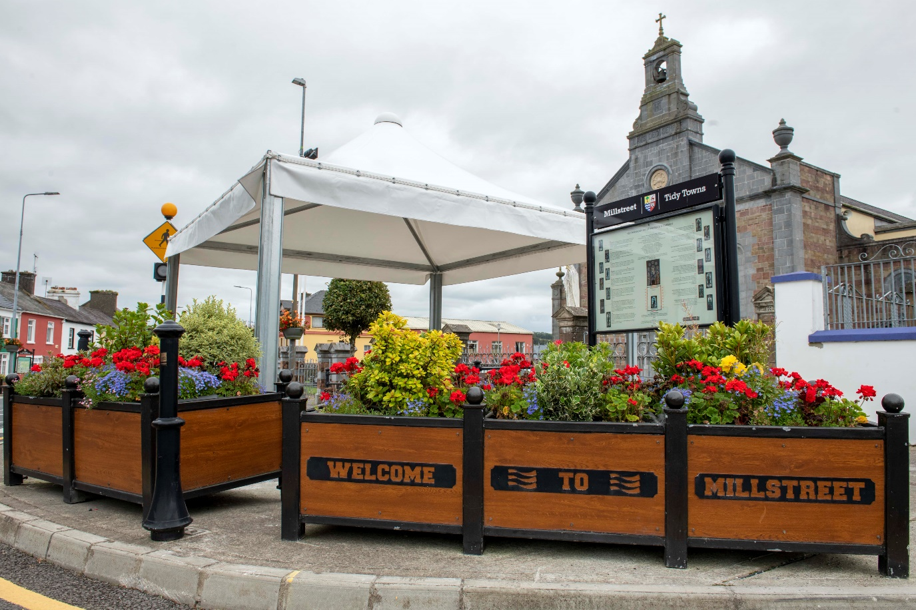
Figure 4 Example of canopy in Millstreet

BANDON
- Removal of street furniture to widen the footpaths to enable safer social distancing.
- Power-washing of town centre streets and footpaths to enhance the visitors first perception of the town.
- Temporarily pedestrianizing of the Bridge Lane to create a pedestrian plaza with age friendly seating, parasols and planting.
- Repurposing of open space on Bridge Lane and South Main Street to enable businesses such as restaurants and cafes bring their businesses out onto the streets, and for safe movement of pedestrians around our town centre.
- Temporarily suspending of pay parking in the town.

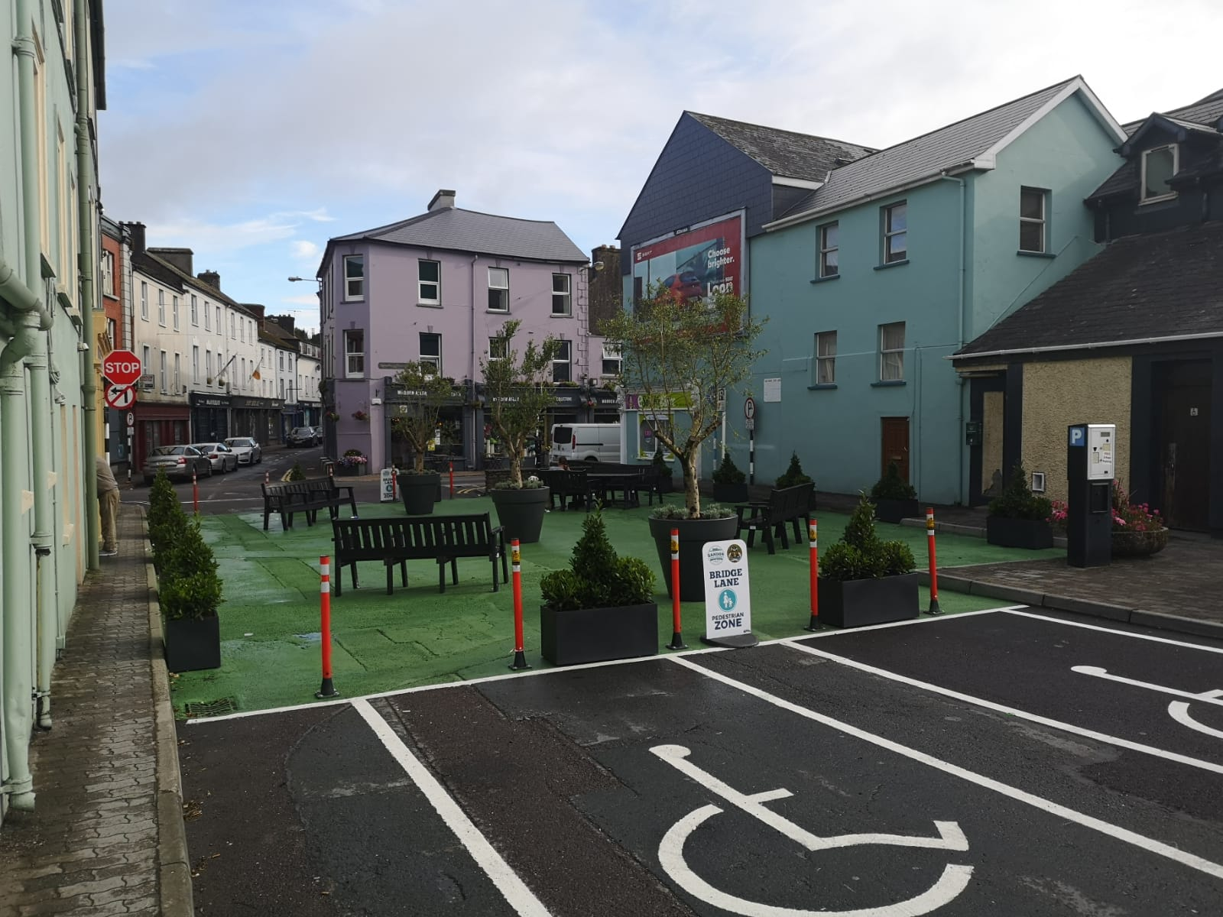
Figure 5 Example of pedestrian plaza in Bandon

KINSALE
- Removal of street furniture and planters to widen the footpaths to enable safer social distancing.
- Power-washing of town centre streets and footpaths to enhance the visitors first perception of the town.
- Temporarily pedestrianizing of the Short Quay to create a pedestrian thoroughfare.
- Closing of Main Street and Market Street on Sundays to create pedestrian thoroughfares.
- Removing of car parking spaces on Pearse Street, Main Street, The Glen and Market Street to enable businesses such as restaurants and cafes bring their businesses out onto the streets, and for safe movement of pedestrian’s around our town centre.
- Moving of farmers market from Short Quay into main Pier Road car park to enable the traders sell their wares in a socially distanced manner.
- Temporarily suspending of pay parking in the town.
CLONAKILTY
- Facilitating town centre pedestrianisation
- Provision of grant towards street entertainment;
- CCC granted street furniture licenses to assist businesses in expanding their business footprint;
- Provision of parklets;
- Provision of Age friendly parking;
- Power washing and declutter of streets;
- Promotion and awareness of key business supports at both a local and national level;
- Agreement to work in partnership to make the town attractive and to incentivize visitors to the town for Christmas 2020 and the 2021 tourism season.
SKIBBEREEN
- Grant provision towards street furniture and canopy on public space;
- CCC granted street furniture licenses to assist businesses in expanding their business footprint;
- Public realm enhancement on North Street and Main Street;
- Grant towards provision of street entertainment each Wednesday and Saturday;
- Provision of Age friendly parking;
- Power washing and declutter of streets;
- Promotion and awareness of key business supports at both a local and national level;

BANTRY
- CCC granted street furniture licenses to assist businesses in expanding their business footprint;
- Provision of Age friendly parking;
- Power washing and declutter of streets;
- Promotion and awareness of key business supports at both a local and national level;
- Provision of street furniture in public areas.
DUNMANWAY
- Grant provision towards street furniture and canopy on The Square;
- Works commenced on the development of a sculpture garden and amenity area on Old VEC Site;
- CCC granted street furniture licenses to assist businesses in expanding their business footprint;
- Provision of Age friendly parking;
- Power washing and declutter of streets;
- Provision of additional crossing points for pedestrians;
- Promotion and awareness of key business supports at both a local and national level;
CASTLETOWNBERE
- In the main, a reactionary policy was adopted in Castletownbere where the town team agreed to deal with issues if and when they arose;
- Grant provided for provision of street furniture at St Peter’s Church.
SCHULL
- Grant provision towards street furniture on public space;
- CCC granted street furniture licenses to assist businesses in expanding their business footprint;
- Removal of some parking to facilitate additional trading space to businesses;
- Provision of Age friendly parking;
- Power washing and declutter of streets;
- Promotion and awareness of key business supports at both a local and national level;

ROADS DIRECTORATE
A key priority from the outset was to ensure that the County towns would be attractive places to visit and do business in, and that public safety would be to the fore. The priority was to embark on a deep cleaning programme while also reviewing town centres layout to identify measure which would facility safe pedestrian access and mobility having regard to social distancing measures.
The countywide work programme incorporated a broad range of measures including, but not limited to:
- Street Power Washing & Cleaning
- Sign & bollard Cleaning & Improvement
- Decluttering of Footpaths (relocation of bins, planters & signage)
- Localised repairs to Footpaths
- New planterboxes and planting of flowerbeds
- Flexible parking bollards to widen footpaths
- Additional Road markings
These measures were implemented at an early stage and were instrumental in encouraging footfall to our town high streets.

ECONOMIC DEVELOPMENT
The LEOs of Cork North & West and South Cork were represented on each of the 23 Project ACT Town Teams and information was provided to each meeting on the supports available to small business throughout the period. As supports evolved during the progression on the COVID crisis updated supports and activities were notified to each meeting.
Crucial to small business was finding outlets to engage with their customers during the forced lockdown and many responded by seeking new outlets online. During the period of Project ACT over 600 applications were received for Trading Online Vouchers to support these businesses to trade online for the first time. Over 700 applications were also received for Business Continuity Vouchers to help businesses in all sectors to look at the immediate issues that they were faced with as a result of the impact of COVID-19 on them.
LEOs ensured that the business communities were kept informed of all the supports that were emanating from a wide range of public sources and provided to each ACT meeting a summary of these. Business organisations were encouraged to share this information with their memberships and as a result there was a very significant demand for the online Business Advice Clinics, the LEO mentoring supports and the LEO training programmes all of which moved to an online delivery model within two weeks of the initial lockdown in March. All services of the LEOs including all programmes were made available free of charge to participants and this will continue for the duration of the crisis. The LEOs also provided ongoing information and a strong message that all businesses on the rates base should be looking at the Restart Scheme that our colleagues in the Economic Directorate were delivering as this was a very significant cash resource that businesses should be availaing of.
A series of Webinars were also developed in support of the reopening of our towns and 8 of these were delivered with some 350 business owners attending. Demand for these webinars will be monitored and further scheduled as necessary.
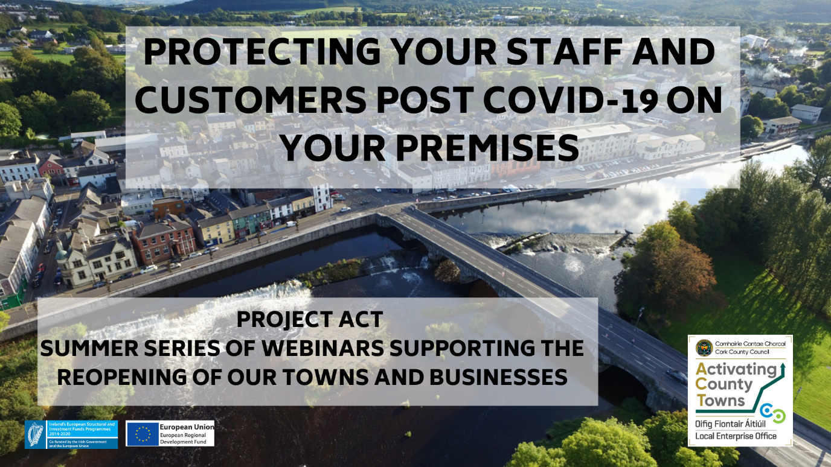
In addition, Cork County Council responded quickly and effectively to the rollout of national funding initiatives for business. Online applications systems were developed in order to facilitate business in making application for the Business Restart Grant schemes, and applications were processed in a timely and efficient manner.

TOURISM
Community Response Initiative – Wellbeing Arm
The Council’s Tourism Office played a key role in contributing to the Council’s Culture Team Response, with input also being provided by the Library, Heritage, and Arts sections. Initiatives were also included from the Wellbeing Office and Healthy Ireland.
Content contributed over a period of three weeks included the following:
Video content - Cork County Council attraction footage such as Spike Island, Camden Fort Meagher, Skibbereen Heritage Centre, virtual tour of Michael Collins House, Clonakility.
Tourism Marketing Initiatives supported by Cork Co Council such as Munster Vales, Cork Harbour Islands and 10 short videos produced by Pure Cork.
Festival & Events Footage supported by Cork Co Council such as Ironman and West Cork Music etc.
Press releases issued on Tourism Capital Project directly undertaken by Cork Co Council or Community supported initiatives such as St Mary’s Collegiate Church, Youghal, Kinsale Museum Upgrade Works, Beara Bridle Way and the Sam Maguire Passport Trail.
Festivals & Events
Established status of Cork County Council supported festivals & events under Local Festival Fund and Economic Development Fund.
Virtual & rescheduled Events -Provided financial and marketing support to festivals & events who decided to hold virtual events such as Baltimore Fiddle Fair, Ballydehob Jazz Festival, West Cork Chamber Music Festival and West Cork Literary Festival. Rescheduled festivals &events taking place in Q4, 2020 will also be supported.
Cancelled Festivals & Events – Many festivals were cancelled and in these cases we assisted financially supporting the costs incurred prior to cancellation.
Project ACT – Town Meetings – Following initiation of Project ACT in mid May representatives from Tourism provided continuous updates at these town meeting on the following areas as required:
- Failte Ireland Supports
- Festival Supports
- Visit Cork Supports
- Development of Cork Co Council GIS Interactive Tourism Map
- Town Videos
GIS Interactive Tourism Map – Rediscover Cork County & Associated Videos under Project ACT
One of the recurring themes mentioned under Project ACT was the promotion of local areas to create awareness of the range of offerings available for both locals and visitors alike which in turn would support businesses and communities.
This led to the commencement of the development of this map in late May which was managed by the Tourism Section in conjunction with the ICT Directorate and was launched in late June at Full Council. A key feature of the ‘Rediscover Cork County’ GIS Tourism Map is the ‘Near Me’ function which enables the user to insert their location or town of preference within a radius of up to 100 kilometres. The map will then display all nearby attractions within that area and generate directions to the attraction or activity of choice. The user can filter under 12 categories including Attractions, Walking and Cycling, Activities, Nature & Gardens, Golf Courses, On the Water, Beaches, Family Fun, Arts, Culture & Heritage, Tourist Offices, Craft & Food Experiences.
Each of the 23 towns under Project ACT has a clickable ‘quick town link’ giving a close view of what’s within a town, as well as providing links to dining out and accommodation options in the area.
A one minute infographic video was also developed which highlights how to maximise the use of the map.
Short promotional videos for each of the 23 towns and surrounding areas which are now incorporated into the ‘quick town links’ section of the map were also developed.
Adverts were placed in relevant newspapers to promote the map
Flyers/business cards were developed and distributed to hotels, attractions, tourist offices etc promoting the availability of the map
Social Media Campaign undertaken
The map is available to view on:
https://www.corkcoco.ie/en/rediscover-cork-county
COMMUNICATIONS
The Council’s Communications Office played a pivotal role throughout the Project ACT initiative, with a key focus of ensuring that the objectives, deliverables and achievements of Project ACT were communicated to the broadest possible audience. This extended from facilitating press releases, to planning and organising photo calls as well as media/radio/TV interviews. This ensured a broad public awareness of the initiative and the associated messaging proved highly successful in attracting positive feedback and commentary in relation to the Council’s pioneering initiative under the programme as evidenced in the following graphics:

CONCLUSION
Project ACT continues to be a success. It has delivered a framework and a structure which supports positive engagement and collaboration at a local town level.
Some consistent outcomes that have been achieved across the County, through the hard work of those involved, include:
- Significant improvement to town presentation and layout
- Imaginative re-purposing of public areas, e.g. outdoor seating, parkets, covered spaces etc
- Targeted approach to promoting tourism across our county towns - “Rediscover Cork”
- The achievement of a broad public awareness of CCC’s contribution to restarting the county’s economy through the imaginative and ambitious communications campaign
- The managed approach to the rollout and delivery of the Business Restart Grants in a user friendly and efficient manner
Focused targets and interventions have been put in place ensuring that appropriate supports were put in place for the issues that mattered to businesses and communities across the County. It is fair to say that the county towns have adapted really well to the challenges presented by Covid-19 and this is evidenced by the largely positive feedback.
Cork County Council will continue to work with the various groups through the town teams as the evolving challenges posed by Covid-19 are met and overcome with the relationships built being invaluable moving forward
As Chief executive of Cork County Council, Tim Lucey, said at the commencement of Project ACT;

“Cork County Council was at the forefront of the Community Call initiative, but we also recognised that the road needed to be prepared for life after COVID-19. There are many challenges that lie ahead, but by taking this action now and investing in our communities and our businesses, we can plan with a degree of confidence. From making public spaces suitable for social distancing, to supporting businesses through various initiatives, Cork County Council will do everything it can to support the entire community. This is the first time in the Council’s history that activity of this scale has been focused directly on towns and their communities. Our staff will work directly with businesses and communities, as we weather this storm. We started this together, and we will finish it together.”

This item was marked as read.

4. Business Prescribed by Statute.

None.

5. Notices of Motion.

5.1.1 Cllr. Danielle Twomey, received on 26th August, 2020.

“That this Council investigate and implement measures to alleviate the levels of noise pollution being experienced by residents of Broomfield from the high level of traffic on the Broomfield spine road”.

Mr. Dave Clarke, Senior Executive Engineer informed the Members that resurfacing works under the Active Travel Measure Scheme are to take place in Broomfield and stated that the old ‘cushion’ style ramps on the Spine Road would also be removed and replaced by new full width ramps and or/pedestrian crossings under this scheme which would greatly help in reducing noise levels in this area.

5.1.2 Cllr. Danielle Twomey, received on 26th August, 2020.

“That this Council install a pedestrian crossing in the Upper Aghada Village to facilitate residents and the nearby school”.

Cllr. McCarthy seconded this motion.

Mr. Dave Clarke, Senior Executive Engineer will investigate this matter and will revert back to the Members on same.

5.1.3 Cllr. Danielle Twomey received on 26th August, 2020.

“That this Council install speed ramps in Beechwood Court and Beechwood Drive to alleviate the speeding issue in the estate and to help uphold the safety of residents”.

Mr. Dave Clarke, Senior Executive Engineer will investigate this matter.

5.1.4 Cllr. Noel Collins, received on 15th September, 2020.

“Council report on the termination of the public water supply to parts of Cahermone, Midleton, for long periods, much to the inconvenience of residents, and report, on source of the problem, and with whom does the responsibility rest, to investigate, to prevent a recurrence of the problem”.

Mr. Joe McCarthy, Municipal District Officer, informed the Members that he will refer this Motion to Irish Water.

5.1.5 Cllr. Noel Collins, received on 15th September, 2020.

“That funding be made available, from the Government Department responsible for the dredging of rivers, and to make funding available for the dredging of the two Midleton rivers, Roxborough and Owenacurra, and the building up of banks on both, now collapsing, with every rain-storm, plus dredging to the rivers, now heavily polluted”.

Mr. Joe McCarthy, Municipal District Officer informed the Members that a report was circulated to the Members earlier this year regarding the Owenacurra River, the Municipal District Officer will re-circulate this report.

The Municipal District Officer informed the Members that the dredging of both rivers, if necessary, would be considered in the context of the Midleton Flood Relief Scheme.

5.1.6 Cllr. Noel Collins, received on 15th September, 2020.

“To prevent flooding in some areas in the town, Council consider the laying of larger drainage piping to accommodate frequent flood waters, and help eliminate the cost to traders and householders, in mopping-up and house repairs, as so happens, under the current drainage system”.

Mr. Joe McCarthy, Municipal District Officer, informed the Members that drainage works are being considered under the Midleton Flood Relief Scheme.

5.1.7 Cllr. Mary Linehan Foley, received on 28th September, 2020.

“Any update on resurfacing works for Sweetfield Estate, Youghal”.

Mr. Dave Clarke, Senior Executive Engineer informed the Members that these works will be considered should a budget become available.

5.1.8 Cllr. Mary Linehan Foley, received on 28th September, 2020.

“Could safety measures be put in place for North Road exiting the Amenity Site as it is a blind area”.

Mr. Dave Clarke, Senior Executive Engineer informed the Members that he has checked the accident history on this road as far back as 2000 which informed him that just two accidents had occurred at this area within the said timeframe. In the meantime the Engineer informed the Members that a hawthorn tree in the area could be cut back which would help the situation here.

5.1.9 Cllr. Mary Linehan Foley, received on 28th September, 2020.

“Council we look at the grant application for Community Centre, Youghal, as they informed me that the application was in but have heard nothing”.

Mr. Joe McCarthy, Municipal District Officer informed the Members that €1,000 from the grant applications had been held in reserve, €300 of which has been committed, the Municipal District Officer stated that €700 which could be allocated to the Community Centre, Youghal. The Members fully agreed with this proposal.

5.1.10 Cllr. Ann-Marie Ahern, received on 29th September, 2020.

“That Developments/Housing Estates under the charge of Cork County Council are inspected regarding the felling of trees that are close to properties where they may cause damage to dwellings during a storm”.

Cllr. Linehan Foley seconded this motion.

Cllr. Quaide proposed that any tree that is being considered for felling or cutting should be assessed by a qualified arborist.

Mr. Joe McCarthy, Municipal District Officer informed the Members that once Cork County Council takes estates in charge they take responsibility for roads, footpaths and public lighting within the said estate, Irish Water takes responsibility for water services (water supply and waste water for sewers and that maintenance of open spaces within estates are not taken in charge by Cork County Council and this remains the responsibility of the residents. Cork County Council has just under 100 estates in its charge in the East Cork Municipal District and to fell one tree in each of these estates per year would cost the Council €120,000 a budget which Cork County Council does not have.

The Municipal District Officer stated that the objective of Cork County Council is to maintain and retain as many trees as possible.

5.1.11 Cllr. Ann-Marie Ahern, received on 29th September, 2020.

“Repair to pipe causing water to run on the road at Ballykilty, Killeagh, (outside property P36 NP44 for identification purposes) and damage to a private dwelling”.

Mr. Dave Clarke, Senior Executive Engineer informed the Members that a drainage pipe which was broken at this location was repaired by a utility company and stated Cork County Council carried out drainage works on one of the roads which brings water down to the crossroads. The Engineer informed the Members that he will review this road during the next bout of rainfall.

    - Cllr. Ann-Marie Ahern, received on 29th September, 2020.

“Update on the appointment of caretaker at Mogeely Old + New Cemetery”.

Mr. Joe McCarthy, Municipal Distract Officer informed the Members that interviews were held recently for the position of a Cemetery Caretaker which included Mogeely Cemetery and stated that the Personnel Department have confirmed that it is their intention to offer the position to a member of the interview panel.

    - Cllr. Liam Quaide, received on 29th September, 2020.

" That the Municipal Council would urgently repair/resurface the road known as the "Windy Boithrin" in Glenbeg, Dungourney, and the road leading to it - Sandy Hill to Stuic road.
(coordinates: 51*57'25.3"N, 8*07'49.8W.)

The Dungourney school bus currently uses this route.

Urgent resurfacing also needed for the nearby Youngrove to Ballymartin Road.
Also, that the Council would place signage identifying these roads in this area, as there are currently none in situ”.

Mr. Dave Clarke, Senior Executive Engineer informed the Members that he will inspect this area for resurfacing works and stated that funding is only provided for road number signage for local roads intersecting National and Regional Roads.

    - Cllr. Liam Quaide, received on 29th September, 2020.

“That the Municipal Council would look into accessing Climate Adaptation funding for works that need to be done to bolster the sea wall at Roches Point into the long-term. Immediate repairs to the foot of the wall from recent storm damage also need to be carried out".

Mr. Dave Clarke, Senior Executive Engineer informed the Members that he will look at these works and suggested that Cllr. Quaide contact the Coastal Management Section in relation to this motion.

    - Cllr. Liam Quaide, received on 29th September, 2020.

“That the Municipal Council would write to the Minister for Agriculture to investigate the sudden closure of the Midleton Country Market in June, and re-open the market if the basis for its closure does not stand up to scrutiny”.

Cllr. McCarthy seconded this motion.

Cllr. McCarthy stated that she had written to the Department of Agriculture regarding this motion and informed the Members that she had received a reply regarding the matter. She would support writing once again to the Department of Agriculture, Cllrs. Hegarty and Collins also supported this.

    - Cllr. Michael Hegarty, received on 30th September, 2020.

“Footpath repairs Main Street, Ladysbridge”.

Mr. Dave Clarke, Senior Executive Engineer informed the Members that he will investigate these works.

    - Cllr. Michael Hegarty, received on 30th September, 2020.

“That an immediate audit and assessment be carried out on the workings of the Traffic Lights in Castlemartyr”.

Cllrs. Twomey & Ahern seconded this motion.

Mr. Dave Clarke, Senior Executive Engineer informed the Members that in order to advance this motion it would have to go to Directorate level to seek funding from the TII. The Engineer informed the Members that a traffic count survey was carried out in September 2013 from Castlemartyr to the Two Mile Inn which saw 463,000 vehicles passing through the village, this rose to 512,000 in 2019 and fell slightly to 499,000 in September 2020.

The Engineer informed the Members that a Traffic Lights Maintenance Contractor would have to investigate this matter and stated that he will forward the motion to the Director of Services se see if funding could be sought for this matter.

    - Cllr. Michael Hegarty, received on 30th September, 2020.

“What other footpath repairs will be carried out in the East Cork Municipal District, in particular, the footpath and flooding in Ballymacoda Village”.

Mr. Dave Clarke, Senior Executive Engineer informed the Members that solutions to the issue remain to be established and the item remains on the drainage works list.

The Engineer informed the Members that some localised repairs have been carried out in Youghal including the Bus Stop outside the butchers shop in the Strand area, Bun Scoil and at the Strand Church. The Engineer stated that he will give an update to the Members on the footpath programme at the next Municipal District Meeting.

    - Cllr. Susan McCarthy, received on 30th September, 2020.

“That this Council, as resolved unanimously at September's meeting, discharge the unspent funds under the 2019 TDF towards the feasibility study to be carried out by Midleton Community Swim and Sports Centre steering group”.

Cllr. McCarthy informed the Members that there is €15,000 in unspent funds and proposed that it go towards funding this study. Cllrs. Twomey and Hegarty seconded this proposal.

    - Cllr. Susan McCarthy, received on 30th September, 2020.

“Upgrades to road at White Bay to Roches Point”.

Mr. Dave Clarke, Senior Executive Engineer informed the Members that this area is a good candidate for consideration for next year’s Road Programme.

    - Cllr. Susan McCarthy, received on 30th September, 2020.

“That Council carry out repairs to wall at Churchtown Cemetery and make good to tree damaged during Storm Emma”.

Cllr. Hegarty seconded this motion.

Mr. Joe McCarthy, Municipal District Officer informed the Members that this cemetery is maintained by Ballintotis Community Council and stated that he has asked the Assistant Engineer to inspect these works and seek a quotation for same. The Municipal District Officer stated that funding is going to be a problem as there are 27 graveyards and cemeteries in the East Cork area to maintain, in the meantime an estimate will be sought and he will see if he can seek funding for these works.

6) Correspondence.

No Correspondence was received.

This concluded the business of the Meeting.

